n

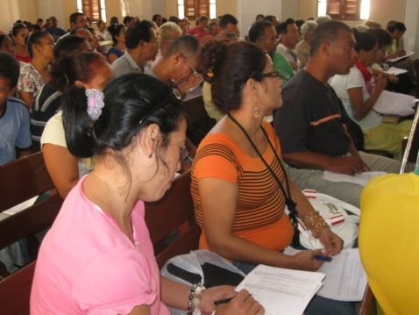



James G. Adams
Director
Latin American Ministries
“…and how shall they HEAR…?”
(Romans 10:14)
Praise & Prayer Letter – July 2026
208 Mary Ann Circle ● Spring Hill, Tennessee 37174-1095 ● 254.715.0206
jamesadams.wp.latinamerica@gmail.com ● www.operationgointernational.c
Sending Church ● Greater Waco Baptist Church ● Waco, Texas 76705-3452 ● Dr. Gerald McKelroy, Pastor

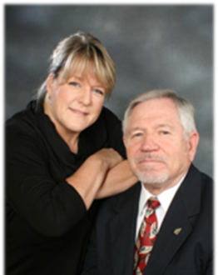

Dear Partners in Prayer & Ministry:

It is good to be back home for a while after several weeks of meetings here in the U.S. and in Guatemala.
It was a blessing to be in a service with our dear friends at Good Hope Baptist Church near Canton, Texas. Pastor Ken Hackney and Belinda and his dear people have been faithful partners for several years now. It is always a blessing to be there.

I was also blest by being with my long-time friend, Pastor Mike Burns and his good people at Rainey’s Chapel Baptist Church near Edgewood, Texas. This was my first visit there and the fellowship with Bro. Mike and his dear wife and sweet people was a refreshing time. God willing, I will be returning for a special meeting next year. I was also privileged to preach at Faith Baptist Church in Brownsboro, Texas where Bro. Mike’s son, Darrell Burns is pastor. What a blessing to be with a young pastor who is doing such an excellent job for the Lord! It does my heart good to see a new generation of Godly men ministering for the Lord! What a joy being in new churches and meeting new friends!

I finished my meetings in Texas in Southlake with my dear friend Pastor Clayton Reed. The wonderful people at Southlake Baptist Church have partnered with us in so many ways for many years now. I was privileged to preach there on Father’s Day to a full house and to participate in their DVBS for a couple of days. Bro. Clay and I have a special connection. He and his family were part of our ministry in Waco for a time. I had the JOY of baptizing him as a small boy after his dad led him to Christ. Years later we reconnected in Southlake. His grandparents, Pastor and Mrs. Roe Reed were precious friends and faithful servants for our dear Lord. Their legacy lives on in their children and grandchildren. It is such an encouragement to see how God has blessed Pastor Reed and Heather and their family in their ministry in Southlake. An added blessing was having my granddaughter, Emily and her husband Trevor and daughter Lilly (my newest great-granddaughter) in the service.

Thank you for praying for our meeting in Guatemala. It was a blessing to minister with Bryan and LeeAnne Treadway and Pastor Rudis Diaz and his wife Ruth and son Rudy. The 65 pastors and leaders who attended were gracious and attentive. They made commitments to train1808 new soulwinners and plant 43 new churches in the next two years. We are praying that God will establish a strong presence for our ministry in churches there. The power of the Gospel in the lives and ministries of faithful Christians sharing that message in their respective communities is always the primary goal of our ministry.

JAMES G ADAMS
OGI Latin America
Romans 8:31-39

